Lê Chấn Huy – QE210078 – SE20D

Lab 3 – ERD and Relational Model (University Management)

1. ERD
Double border = weak entity / identifying relationship; double line = total participation; dashed ellipse = derived attribute; underlined = key.
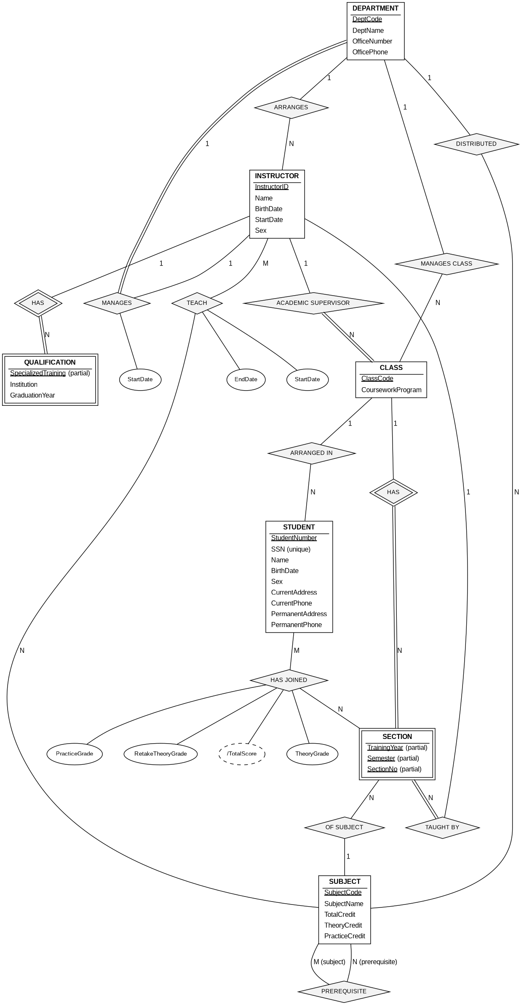
Constraint: the academic supervisor of a class must be an instructor of the department that manages the class.
Derived: TotalScore = 50% TheoryGrade + 50% PracticeGrade. A student passes if TheoryGrade > 4.0 and TotalScore > 5.0; otherwise the student takes a retake exam for the theory grade (RetakeTheoryGrade, empty if no retake).

2. Convert ERD to relational model

Mapping rules applied
- Strong entity → table; weak entity → table with the owner's key added to its primary key.
- 1:N relationships → foreign key on the N side; 1:1 relationships → foreign key on the side with total participation (relationship attributes move with it).
- M:N relationships → separate table with both keys.

Relations
DEPARTMENT(DeptCode, DeptName, OfficeNumber, OfficePhone, ManagerID, ManageStartDate)
INSTRUCTOR(InstructorID, Name, BirthDate, StartDate, Sex, DeptCode)
QUALIFICATION(InstructorID, SpecializedTraining, Institution, GraduationYear)
SUBJECT(SubjectCode, SubjectName, TotalCredit, TheoryCredit, PracticeCredit, DeptCode)
PREREQUISITE(SubjectCode, PrerequisiteCode)
TEACH(InstructorID, SubjectCode, StartDate, EndDate)
CLASS(ClassCode, CourseworkProgram, DeptCode, SupervisorID)
STUDENT(StudentNumber, SSN, Name, BirthDate, Sex, CurrentAddress, CurrentPhone, PermanentAddress, PermanentPhone, ClassCode)
SECTION(ClassCode, TrainingYear, Semester, SectionNo, SubjectCode, InstructorID)
GRADE_REPORT(StudentNumber, ClassCode, TrainingYear, Semester, SectionNo, TheoryGrade, PracticeGrade, RetakeTheoryGrade)
Foreign keys:
- DEPARTMENT.ManagerID → INSTRUCTOR.InstructorID
- INSTRUCTOR.DeptCode, SUBJECT.DeptCode, CLASS.DeptCode → DEPARTMENT.DeptCode
- QUALIFICATION.InstructorID → INSTRUCTOR.InstructorID
- PREREQUISITE.SubjectCode, PREREQUISITE.PrerequisiteCode → SUBJECT.SubjectCode
- TEACH.InstructorID → INSTRUCTOR; TEACH.SubjectCode → SUBJECT
- CLASS.SupervisorID → INSTRUCTOR.InstructorID
- STUDENT.ClassCode → CLASS.ClassCode
- SECTION.ClassCode → CLASS; SECTION.SubjectCode → SUBJECT; SECTION.InstructorID → INSTRUCTOR
- GRADE_REPORT.StudentNumber → STUDENT; GRADE_REPORT.(ClassCode, TrainingYear, Semester, SectionNo) → SECTION
Constraint: CLASS.SupervisorID must refer to an instructor of CLASS.DeptCode.
Unique: STUDENT.SSN. TotalScore and pass/fail are derived, so they are not stored.

